JIRA : Dashboards and Reports

Overview:

Jira Dashboards and Reports are visualization tools used to track project progress, monitor team performance, and support data-driven decision making. They transform raw issue data into meaningful insights for different stakeholders such as QA teams, developers, managers, and product owners.
Dashboards provide a customizable, real-time view, while Reports offer predefined analytical views focused on Agile metrics.

Jira Dashboards

What is a Dashboard?
A Dashboard in Jira is a customizable page that displays multiple visual components called gadgets, each powered by filters or project data.
Dashboards help users:
- Monitor ongoing work
- Track risks and blockers
- Understand team workload
- Share status with stakeholders

Key Features of Dashboards
- Built using gadgets
- Can be personal or shared
- Auto-refreshes with real-time data
- Accessible across projects using filters
- Role-based visibility (QA, Dev, Manager)

Common Dashboard Gadgets
Gadget | Purpose
Filter Results | Displays list of issues from a filter
Pie Chart | Shows distribution by status, priority, assignee
Sprint Health | Sprint progress overview
Burndown Chart | Sprint completion tracking
Created vs Resolved | Issue trend analysis
Average Age Chart | Aging issues identification
Two-Dimensional Filter Statistics | Cross-comparison (e.g., status vs assignee)

Dashboard Use Cases
- QA Dashboard – Open defects, blocked bugs, test-ready items
- Manager Dashboard – Sprint progress, risks, overdue issues
- Developer Dashboard – Assigned tasks, bugs to fix
- Release Dashboard – Issues by version and status

Dashboard Permissions
- View
- Edit
- Share
- Set as default dashboard
Permissions are managed via dashboard sharing settings, not project permissions.

Jira Reports

What are Reports?
Reports in Jira are pre-built analytical views designed primarily for Agile project tracking. Reports focus on trends, progress, velocity, and predictability.
Reports are mostly project-specific and depend on:
- Issue data
- Sprints
- Workflows
- Estimates

Types of Jira Reports
Scrum Reports
- Sprint Burndown Chart
- Sprint Report
- Velocity Chart
- Epic Burndown
- Release Burndown
Kanban Reports
- Cumulative Flow Diagram
- Control Chart
- Cycle Time Report
Issue & Forecast Reports
- Created vs Resolved Issues
- Time Tracking Report
- Workload Pie Chart

Key Agile Reports Explained
Sprint Burndown Chart
- Tracks remaining work in a sprint
- Identifies scope creep and delays
Velocity Chart
- Shows team’s delivery capacity over time
- Helps sprint planning
Cumulative Flow Diagram
- Visualizes work in different statuses
- Identifies bottlenecks
Control Chart
- Shows cycle time of issues
- Used to measure process efficiency

Dashboards vs Reports (Important Difference)
Dashboards | Reports
Customizable | Predefined
Filter-based | Sprint/project-based
Cross-project | Mostly project-specific
Real-time monitoring | Analytical insights
Stakeholder-friendly | Agile team-focused

Best Practices
- Use filters as the foundation for dashboards
- Create role-specific dashboards
- Avoid clutter (limit gadgets per dashboard)
- Keep reports sprint-aligned
- Regularly review and clean dashboards

Veeva / Enterprise Context
- Dashboards used for compliance visibility
- Reports used for audit readiness
- Filters ensure traceability
- Data transparency supports regulated environments

Summary
- Dashboards = Visualization + Monitoring
- Reports = Analysis + Metrics
- Filters & JQL = Foundation
- Essential for Agile teams, QA roles, and interviews

Hands-on Practice:

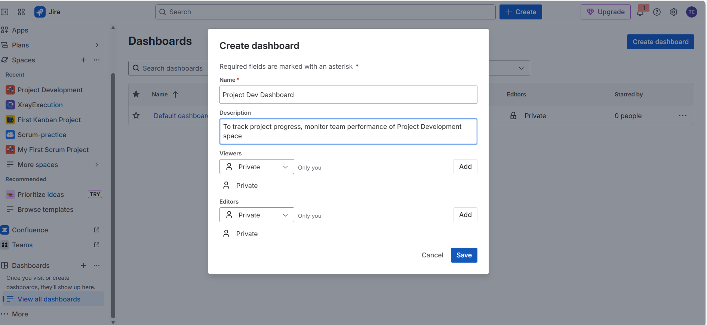

Pie chart as a gadget:

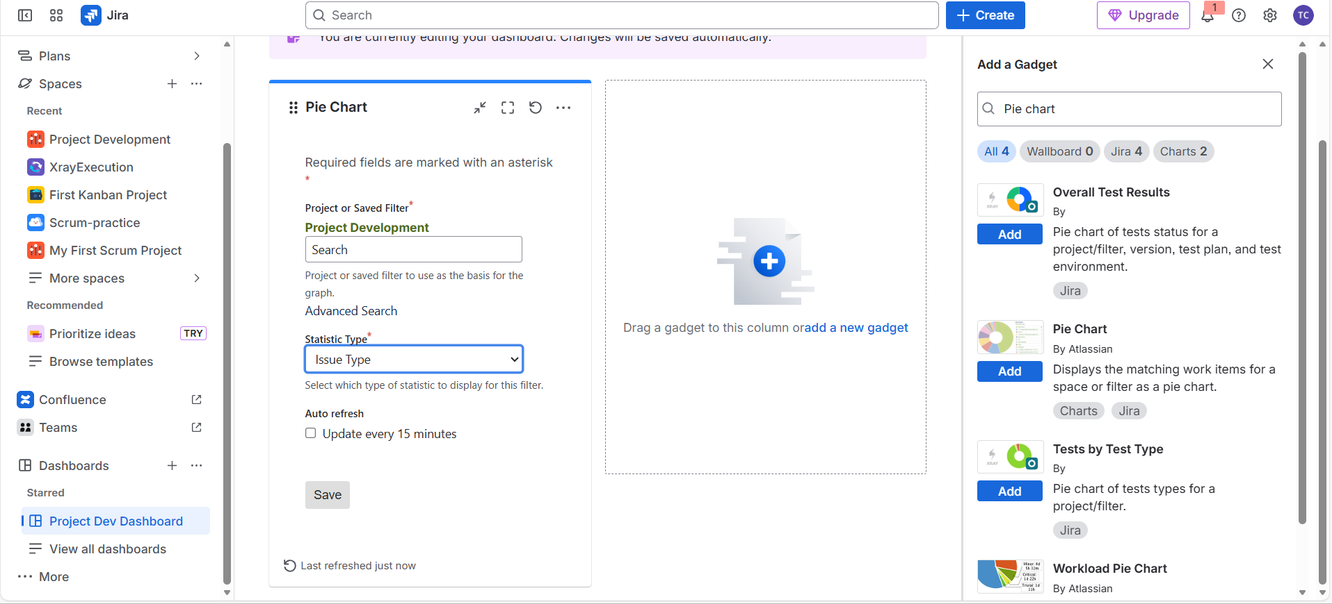

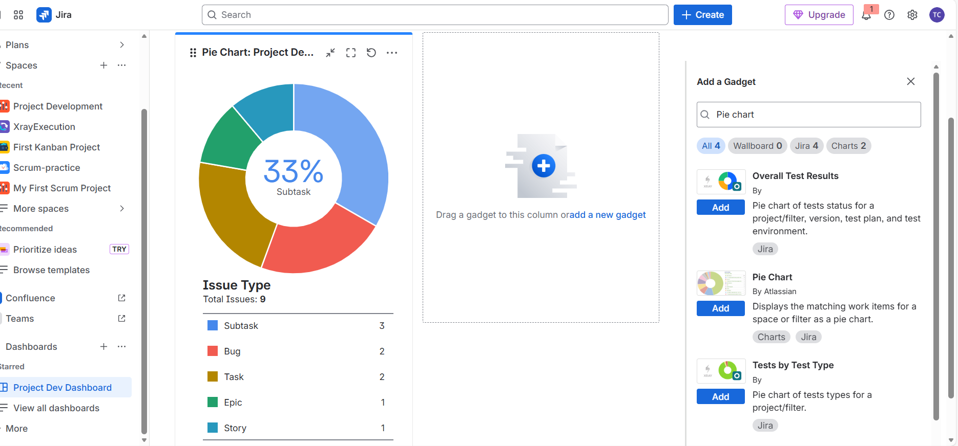
Created vs Resolved chart as a gadget:

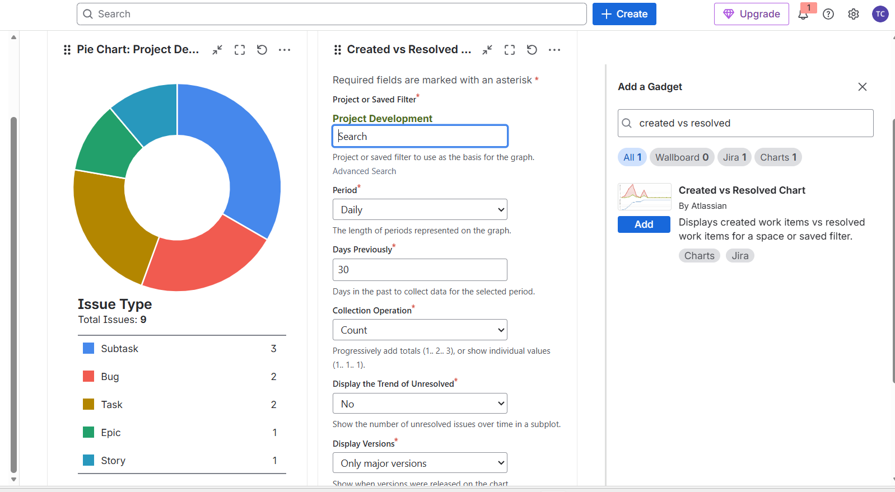

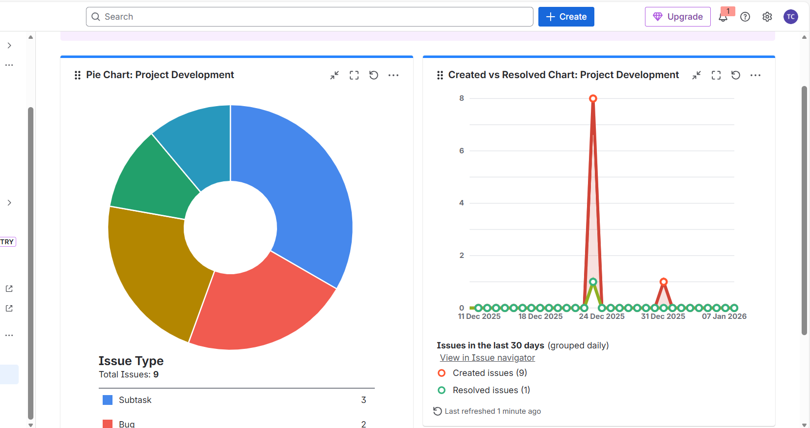

Options present for a dashboard copy, rename, share etc.,

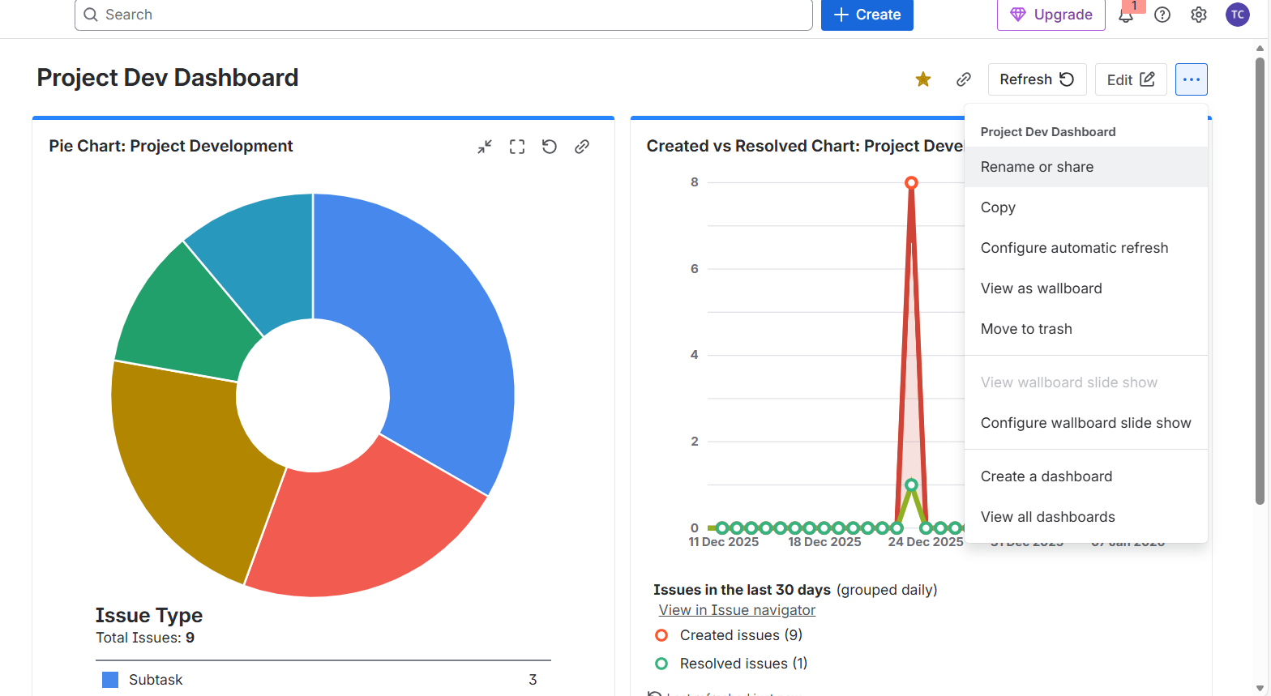

Scrum Reports:

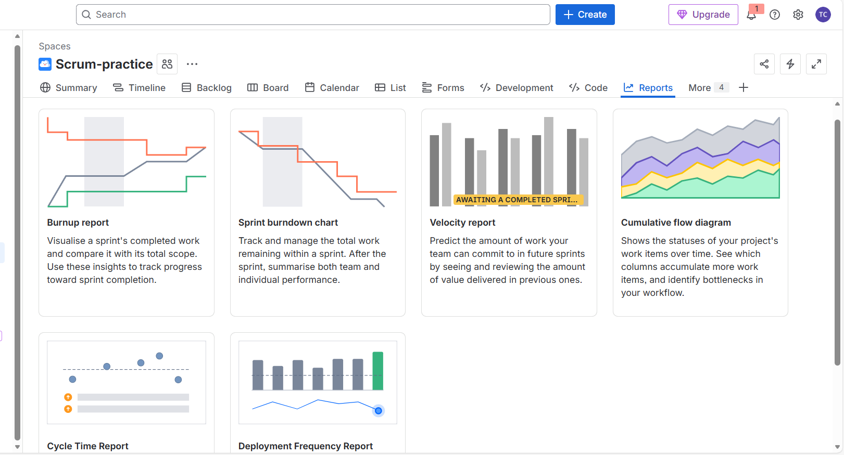

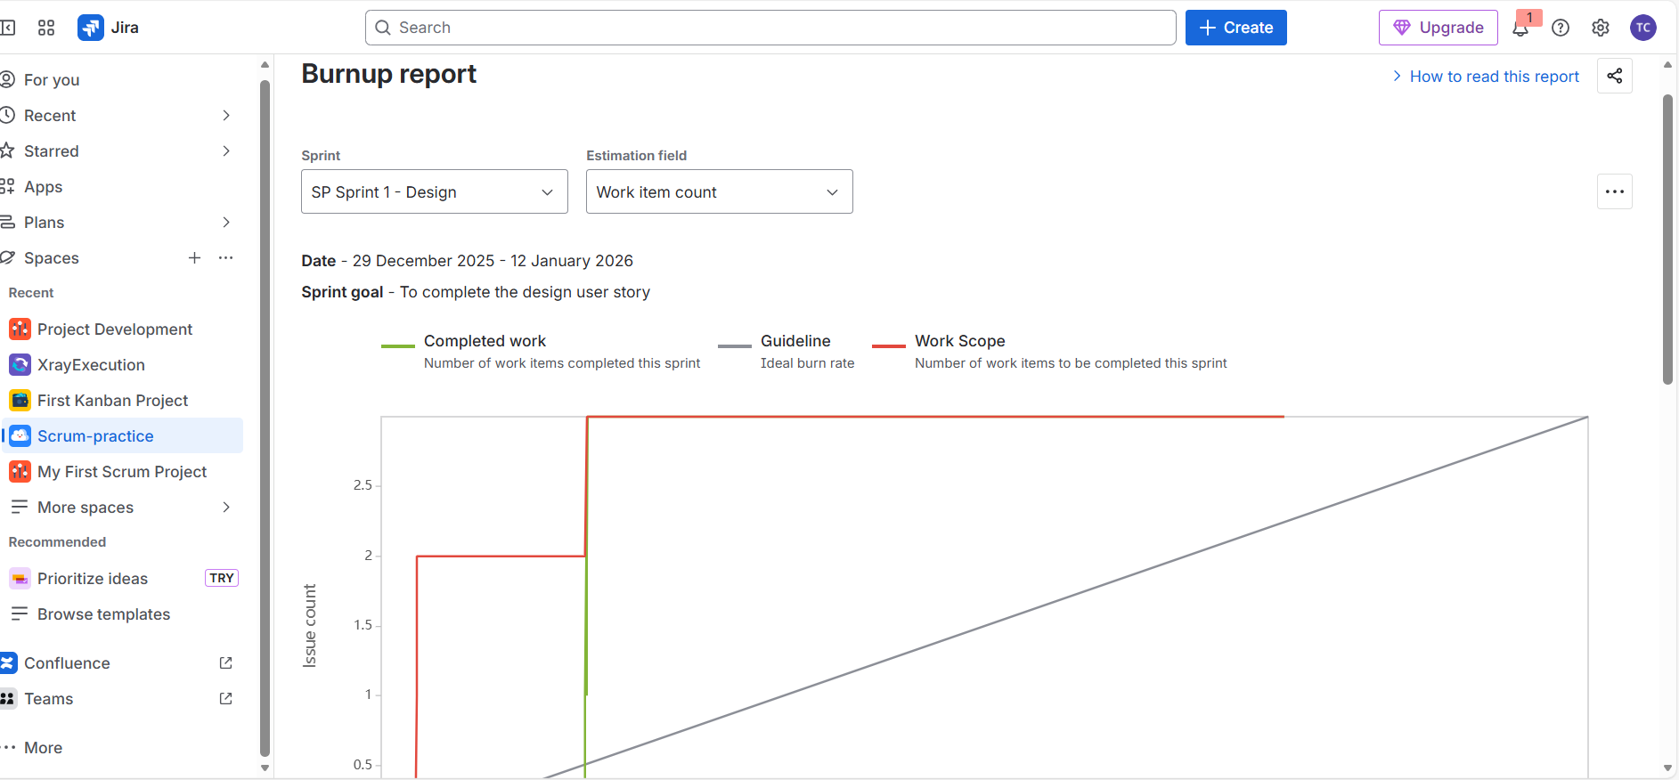

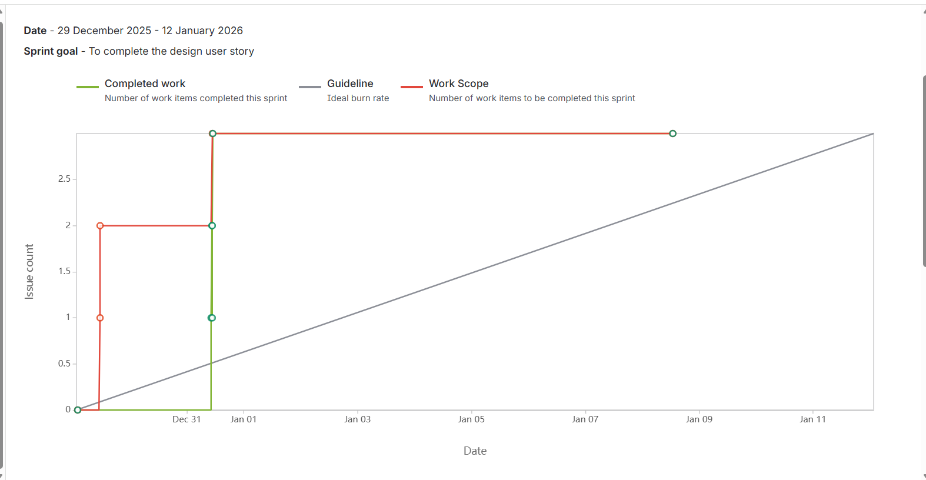

Here’s a clear description about the above Burn-up Report 👇

This burn-up chart shows how work progressed during the sprint 29 Dec 2025 – 12 Jan 2026, with the sprint goal to complete the design user story.
What the chart shows
- Work Scope (Red line):
Represents the total number of work items planned for the sprint.
Here, the scope increased early in the sprint (from 2 to 3 items), indicating scope addition or refinement after the sprint started.
- Completed Work (Green line):
Shows the number of work items actually completed.
Most of the work was completed in a short time window near Dec 31 / Jan 1, rather than steadily across the sprint.
- Guideline / Ideal Burn Rate (Grey line):
Indicates the ideal linear progress needed to complete all work by sprint end.

Key Observations
- Late Completion Pattern
The team completed most of the work towards the beginning of the sprint, but there was no steady daily progress afterward.
- Scope Change Detected
The increase in the red line clearly shows scope creep, meaning additional work was added after sprint start.
- Completion vs Guideline
The completed work crossed the ideal guideline early, which means:
  - Work was finished earlier than expected
  - Or tasks were completed in bulk rather than incrementally

What This Indicates About the Team
- Sprint goal was achieved
- Scope changes were managed successfully
- Work was completed in batches, not continuously
- Planning accuracy could be improved to avoid mid-sprint scope changes

Summary (1–2 lines)
“This burn-up chart shows that the sprint goal was achieved despite an increase in scope early in the sprint. Most work was completed in a short period rather than steadily, indicating batch completion and scope adjustment during the sprint.”

Why Burn-up Is Useful (Compared to Burn-down)
- Clearly shows scope changes
- Separates work completed vs work added
- Better for stakeholder transparency
- Preferred in enterprise and compliance-driven teams

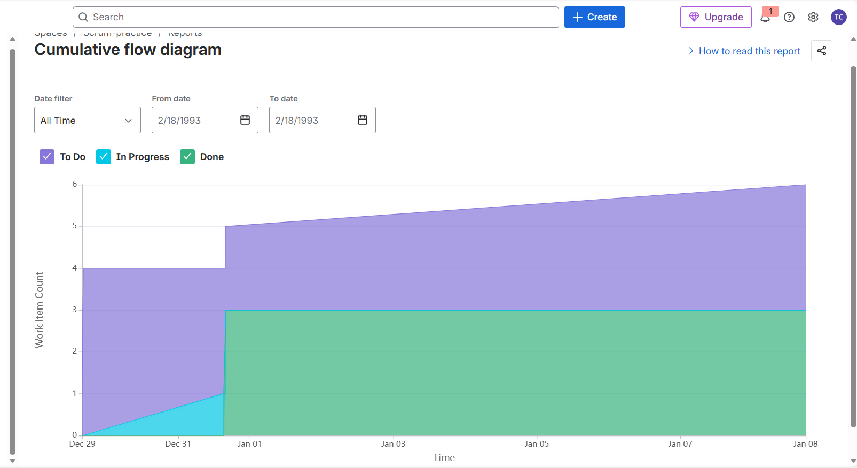

Explanation for the above Cumulative Flow Diagram (CFD) :👇

Cumulative Flow Diagram – Explanation
This Cumulative Flow Diagram (CFD) visualizes how work items moved across different workflow stages (To Do, In Progress, Done) over time for the selected period.
What the chart shows
- To Do (Purple area):
Represents the total number of work items waiting to be started.
The steady increase from 4 to 6 items indicates new work being added to the backlog over time.
- In Progress (Blue area):
Shows work items currently being worked on.
The very thin band (mostly between 0–1) indicates low Work In Progress (WIP).
- Done (Green area):
Represents completed work items.
A sharp rise around Jan 1 shows that multiple items were completed at once, after which the count remained stable at 3 completed items.

Key Observations
- Low WIP (Good Practice)
The narrow “In Progress” band suggests the team avoided multitasking and kept WIP under control.
- Batch Completion
The sudden jump in the “Done” area indicates work was completed in batches, not continuously.
- Backlog Growth
The increasing “To Do” area means new work was added faster than it was completed, leading to backlog growth.
- Flow Stability
The parallel nature of the layers after Jan 1 indicates a stable workflow, but with limited throughput.

What This Indicates About the Team
- Team completed work efficiently once started
- WIP limits were respected
- Work arrival rate was higher than completion rate
- Delivery was not continuous, but event-based

Summary (1–2 lines)
“This cumulative flow diagram shows controlled WIP with batch completion of work. Although the workflow is stable, the growing ‘To Do’ area indicates backlog growth and a delivery rate slower than work intake.”

Why CFD Is Important
- Identifies bottlenecks (wide In Progress area)
- Shows WIP violations
- Helps improve cycle time & throughput
- Widely used in Kanban and Agile maturity assessments

Quick Tip
- Widening In Progress band → bottleneck
- Flat Done line → delivery stalled
- Growing To Do band → over-commitment or scope creep

Kanban reports:

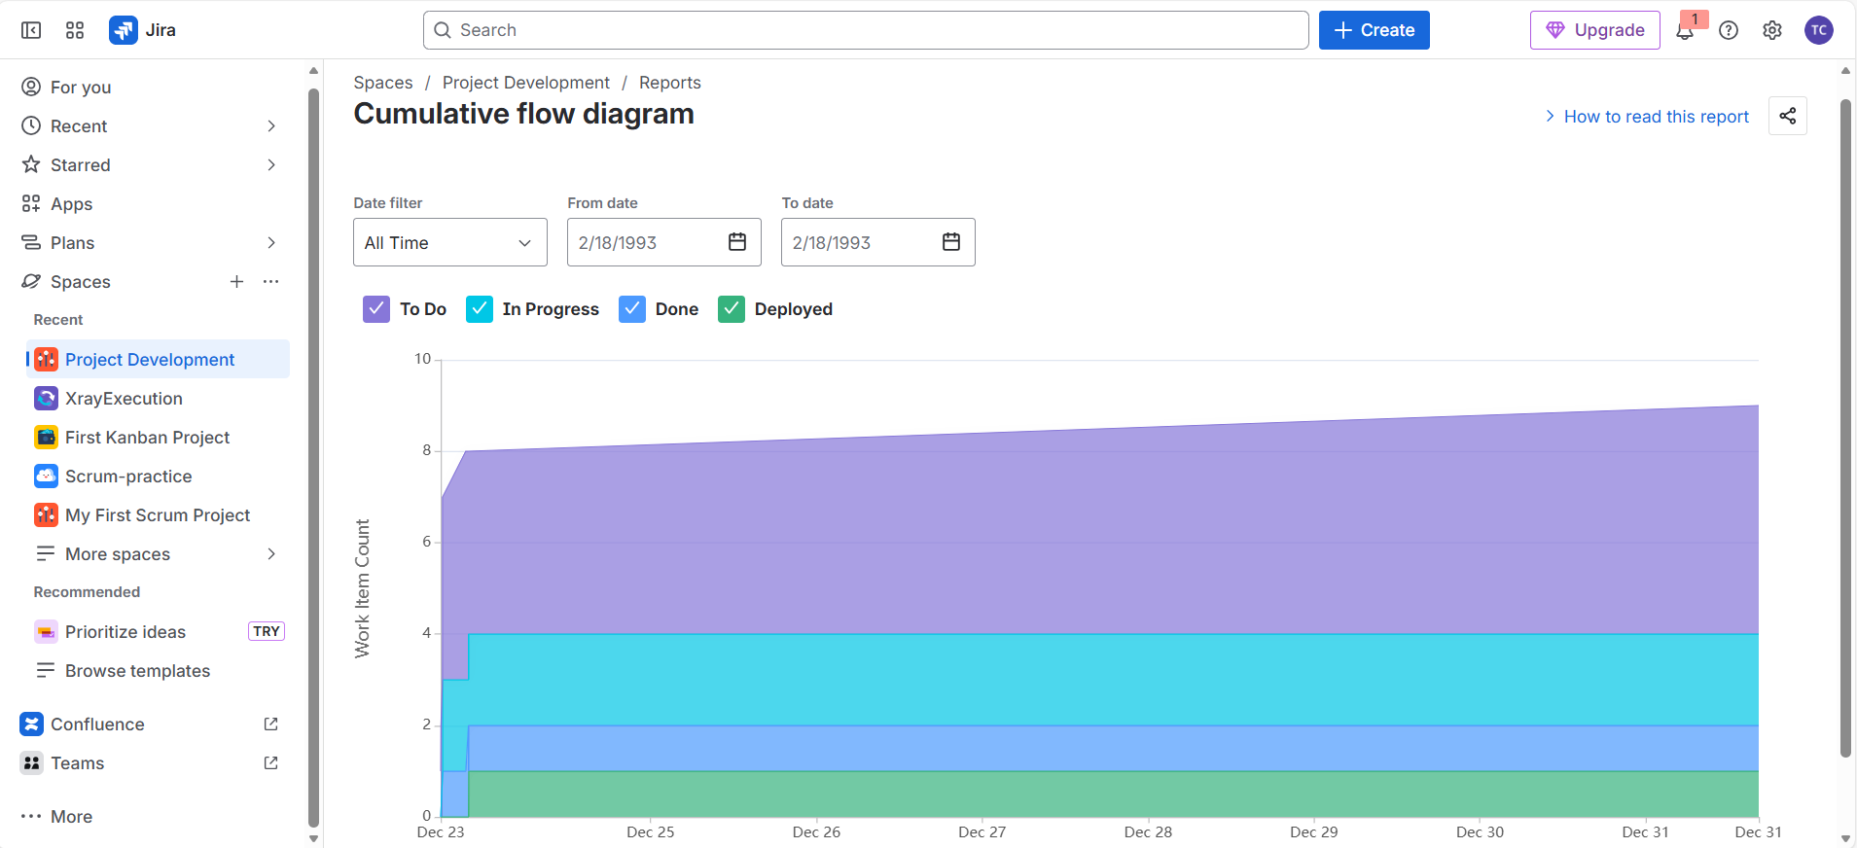

This is a CFD with 4 workflow states: To Do → In Progress → Done → Deployed.
Here’s explanation for the above CFD👇

What the chart shows
- To Do (Purple area):
Represents work items waiting to be started.
The gradual increase from around 7 to 9 items indicates new scope was added continuously during the period.
- In Progress (Cyan area):
Shows items actively being worked on.
The area stabilizes at around 4 items, suggesting the team maintained a fixed WIP limit.
- Done (Blue area):
Represents completed work that is not yet deployed.
The flat line at 2 items indicates work was completed but not immediately released.
- Deployed (Green area):
Shows work items that reached production.
Only 1 item was deployed and remained unchanged, indicating deployment bottleneck or batch releases.

Key Observations
- Stable WIP (Healthy Flow)
The consistent width of the “In Progress” band shows good control over WIP and predictable execution.
- Backlog Growth
The increasing “To Do” area indicates incoming work exceeded delivery, causing backlog accumulation.
- Deployment Bottleneck
The gap between “Done” and “Deployed” suggests work is completing but waiting for release, a common DevOps or approval delay.
- Limited Throughput
Despite steady development, the number of deployed items remained almost constant, highlighting low end-to-end delivery rate.

What This Indicates About the Team
- Development work is stable and controlled
- Team completes work efficiently but releases infrequently
- Deployment stage is the main constraint
- Potential need for CI/CD improvements or faster approvals

Summary (1–2 lines)
“This CFD shows stable development with controlled WIP, but a clear bottleneck at the deployment stage, causing completed work to wait before release and leading to backlog growth.”

Why This CFD Is Valuable
- Highlights where work gets stuck (Done → Deployed)
- Helps identify non-development bottlenecks
- Useful for DevOps, Kanban, and Agile maturity discussions
- Supports decisions around automation and release frequency

